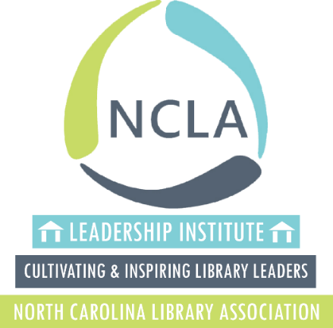

2020 NCLA Leadership Institute
Cultivating and Inspiring NC Library Leaders
Call for Applications

The North Carolina Library Association (NCLA), with support from the State Library of North Carolina, is pleased to issue a call for applications for the NCLA Leadership Institute, which will be held September 16-19, 2020 in Black Mountain, North Carolina.

Applications are due by Friday, March 27, 2020.
The Institute is an intensive four-day residential event that will take place at Black Mountain YMCA Blue Ridge Assembly in Black Mountain, NC. In addition to this four-day event, participation in the Leadership Institute requires the following: a one-year commitment to engage in a group mentor/mentee relationship, attendance at a one-day follow up session held on April 16, 2021 at the Iredell County Public Library, and participation in the 2021 NCLA Biennial Conference on October 19-22, 2021 in at the Benton Convention Center in Winston-Salem.
We look forward to this experience with a new group of future North Carolina library leaders. A typical cohort consists of about 24 participants selected through a competitive application process. Multiple applicants from the same institution or system will be considered.

Mission
The mission of the North Carolina Library Association (NCLA) Leadership Institute is to create opportunities for learning and skill building in leadership and mentoring. The Institute will cultivate an improved understanding of self and others while inspiring participants to serve in leadership roles within the profession at local, state, and national levels.

Eligibility
To participate in the NCLA Leadership Institute, you must be (1) a member of NCLA and (2) currently employed by a North Carolina library. We are seeking participants who desire to grow and positively influence the profession. All interested librarians and library staff are encouraged to apply.

Project Component
An integral part of the NCLA Leadership Institute is the selection by the participant and the sponsoring library of a project that will engage the participant for up to a year after the Institute. Participants are expected to work with their library administrators in advance of the Institute on the identification of possible projects. The projects should be developed by the participants in response to community and/or organizational needs and approved and supported by the library but should not be assigned by the library.

The application does not include the identification and preliminary design of a project. The projects will not be a major focus during the residential portion of the Institute but they will be addressed through discussion of project design ideas and the opportunity to talk to the Institute facilitators and mentors.

Fees
Cost of the Institute, which includes registration, housing and all meals, is $450*. It is preferred that institutional support be provided; however, scholarship opportunities may be available through NCLA sections for those unable to secure financial support. Participants and/or their libraries are responsible for transportation to and from the Institute. The fee does not cover registration for the 2021 NCLA Biennial Conference to showcase results of Leadership Institute projects or the cost for time and resources needed to design and implement projects.
*Due to the generosity of the State Library of North Carolina, NCLA is able to offer a reduced tuition for the Leadership Institute.

APPLICATION MATERIALS AND SELECTION PROCESS
Application Materials
Please provide the following as application for the NCLA Leadership Institute:
- Cover Letter
- Resume
- Two Letters of Recommendation
- Two Essay Responses

General Instructions:
Please submit all application materials as one document (PDF) via email to: ncla.leadership@gmail.com

Cover Letter
In your cover letter, please provide the following:
- Current NCLA membership status
- Contact Information
- Why you want to attend the Institute

Resume
In order to collect uniform information from each applicant, be sure your resume includes the following sections:
- Contact information.
- Education. List all academic degrees and the year received and list any relevant continuing education.
- Relevant work experience. List all library positions with dates for each, and include a brief description of duties for each position. List any non-library positions if you held them for a year or more.
- Professional memberships and activities.
- Community memberships and activities. You may include involvement in communities other than the one in which you currently work.
- Any awards, publications, presentations, or special projects.
- Any relevant volunteer experience.

Letters of Recommendation
Letters of recommendation should be in standard business letter format and should speak to the qualities and skills that you will bring to the Institute.
Submit one letter of recommendation from your library director or other top administrator. This letter should reflect a clear understanding of, and support for, all Leadership Institute activities, as well as knowledge of your work and accomplishments in the library. It should also speak to what the library hopes you will gain from participation in this experience.

Submit one letter of recommendation from another professional colleague that speaks to the qualities and skills that you will bring to the Institute.

Essay Responses
Essay #1 - Describe how the Institute will benefit your library, as well as your personal and professional growth.

Essay #2 - Community focus and connection is a critical aspect of the Leadership Institute experience. Please identify a major issue facing the members in your community and explain how you might address this concern. This could potentially be the focus of your Institute project.

Application Submission

Applications are due by Friday, March 27, 2020. Submissions received after this date will not be considered.
Please submit all application materials as one document (PDF) via email to: ncla.leadership@gmail.com
The subject line of the email message should read: <your last name> <your first name> LI Application. For example: Smith Susan LI Application

Application Review
Complete application packets will be reviewed and scored by the Leadership Institute Planning Committee. Complete application packets must include:
- Cover Letter
- Resume
- Two Letters of Recommendation
- Two Essay Responses

Applicants will be notified May 2020.

Questions:
If you have questions about the application process, please contact Juli Moore at julianne.moore@co.iredell.nc.us

